Meet&Match
Antibody Technologies
31. March 2011
Place: Basel (UBS) Viaduktstrasse 33 (5 minutes from SBB)
Time: 10:00 h – 16 h 12 presentations à 15 minutes
Networking with lunch

I am interested and would like to:
participate in the audience. (Attention! only 30 places available, in case of overbooking BioValley will choose the participants with the best profiles for this event)
I am interested but not available this date, please give me a feed back about the meeting.
I will stay for the buffet yes no

Contact:
Name
Position
Institution/Company
Working group / department
Adress
Telephone N°.
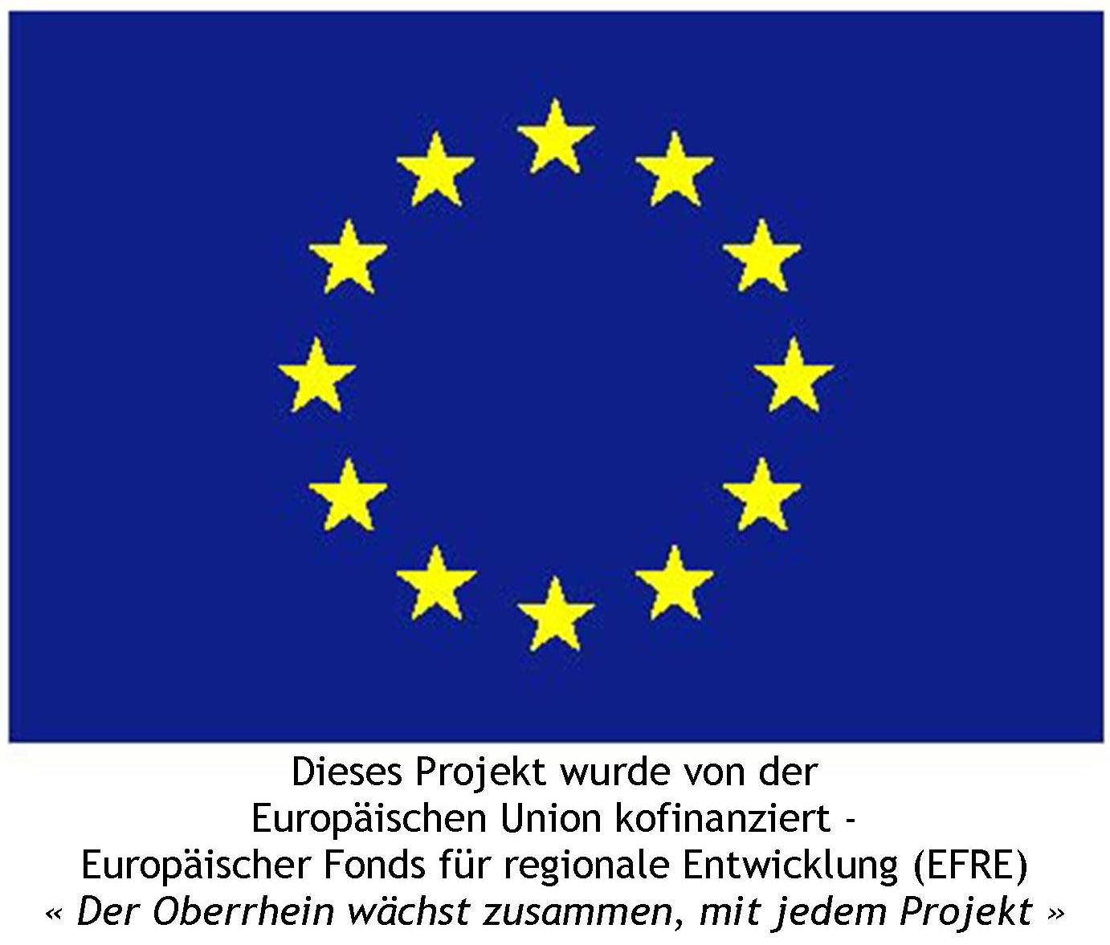

E mail

